Member Responsibilities

1. Functionality requirements gathering, User analysis, and Task analysis:
• All group members,
2. Design a flow chart of the system:
• İsmail Temüroğlu
3. Wireframes/ mockups
• Emre Topcu (High Fidelity) and Kutal Efe Baykal (Low Fidelity)
4. Predictive evaluation
• Emre Topcu
5. Usability Inspection, Usability Testing
• Muhammed Kaan Uman

Functionality requirements gathering

1. The Project provides information about the business including its name, description, services, and information section. Also, if the users want to buy any services there will be a Contact Us section to contact the business about it.
2. In all the pages on the top left there will be a business logo and at the top right side there will be buttons that lead to different pages such as the home page, about us, and forum page.
3. On the home page, the slogan of the business is presented to the user. Whenever a user enters the website, this is the page they will see.
4. If the user clicks on the About Us button, they will see the description of the business after that they can press the slider button to see the company structure.
5. If the user clicks on to Contact Us button, they will see the address and other relevant contact information.
6. If the user clicks on the Forum button, they will see various job opportunities.
7. Whenever the user presses the logo, the user will be taken back to the home page.

User Analysis
1. Possible user age range is between 18-60. It is a site that all people can use without regard to gender, culture, or language.
2. User analysis according to age:
- For the users between 18-25 ages, they can use our services to help them with their start-ups and find partners or apply for jobs.
- For the users between 25-36 ages, they might want to use our other services or apply for jobs.
- For the users between 36-60 ages, they might be investors looking for suitable businesses or the same services as 25-36 age users.
Besides the age categories:
- To find the suitable services,

- To browse our forum,

- To find information about the company.

Task Analysis
Goal: It is our goal to supply our services to all users in need in a reliable and fast way.
Preconditions: There is no precondition to browse the services.

Subtasks:
• Choosing which page, they want to go.
• In the forum page, user should be able to see other businesses and be able to apply the one they choose.
• In contact us page, user should be able to fill in their information and send it to the business.
• In home and about us pages user should be able to use sliders to see different information.
• In the forum page they should be able to sort and filter the available jobs according to the available filter and sort choices.

Where is the task performed?
• This task can be performed anywhere with internet connection.

• You can perform this task in any browser you wish to use.
• There is no restriction to where you are while using this web site.

Are there any restrictions to accomplish the task?
• As long as user is not visually impaired there is no restrictions.

What are similar websites?
• Tencent
• Bytedance
• Kingsoft

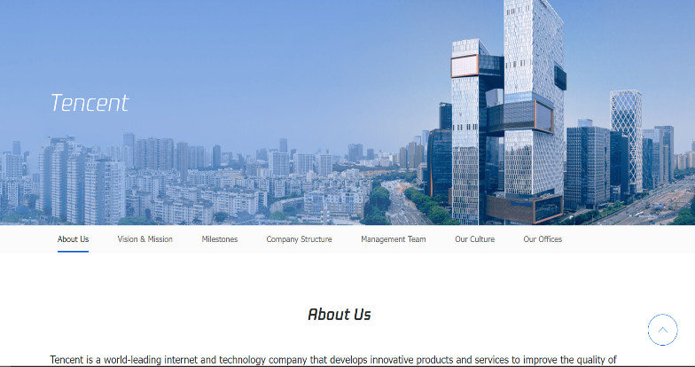
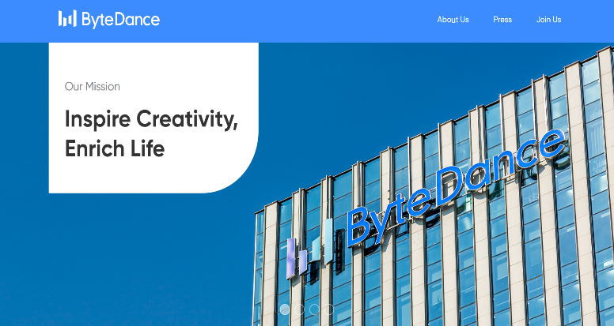

Flowchart

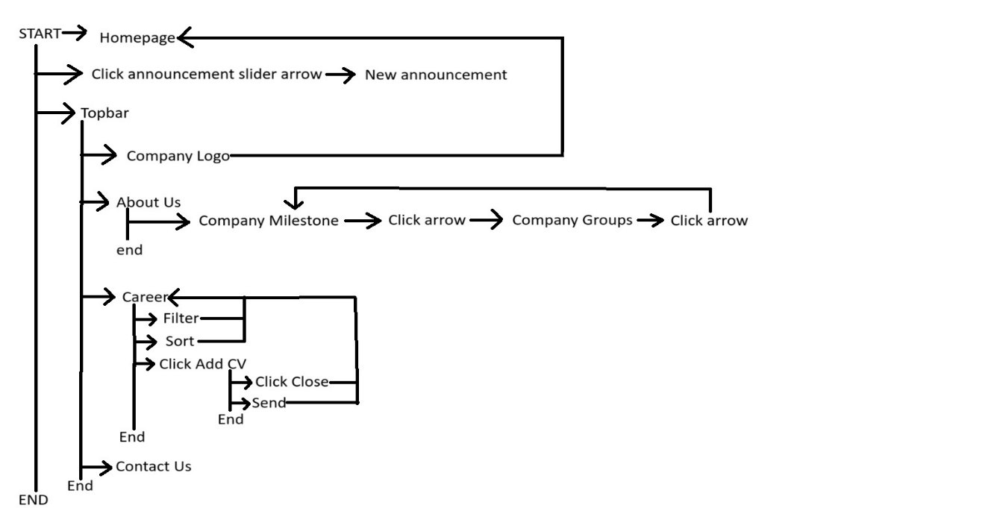

Prototypes (Low and High Fidelity)

Home Page

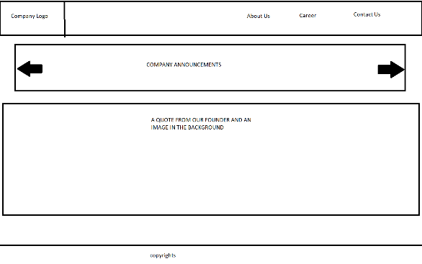
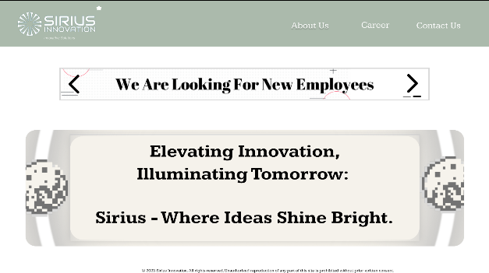
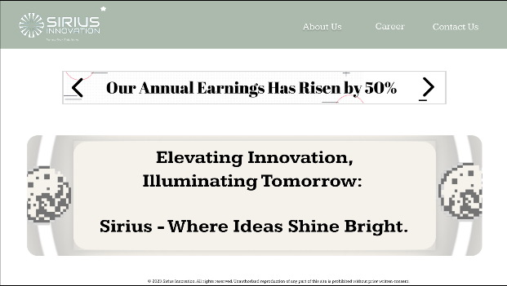

About Us
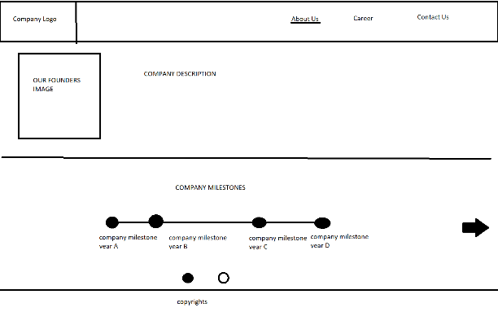
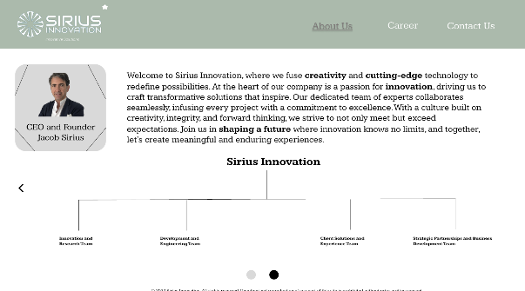
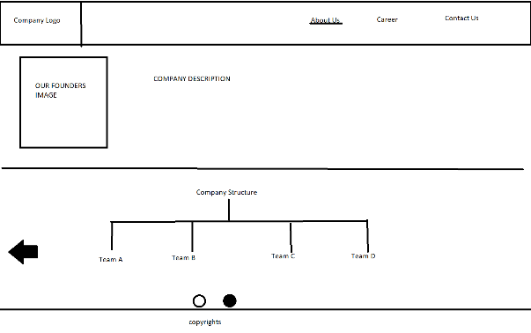
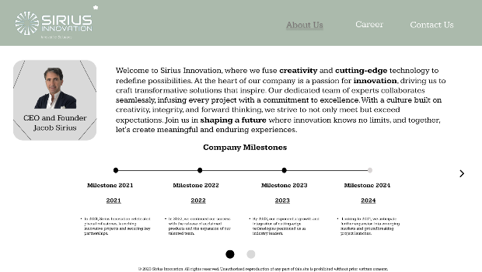

Career
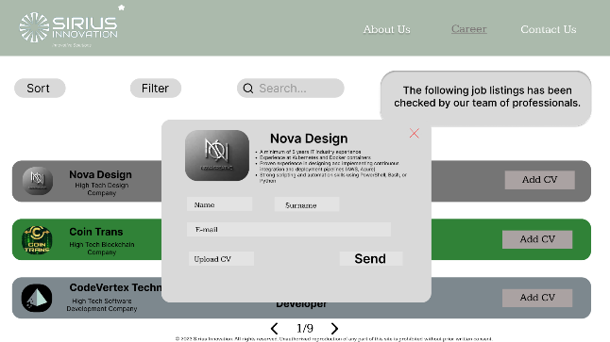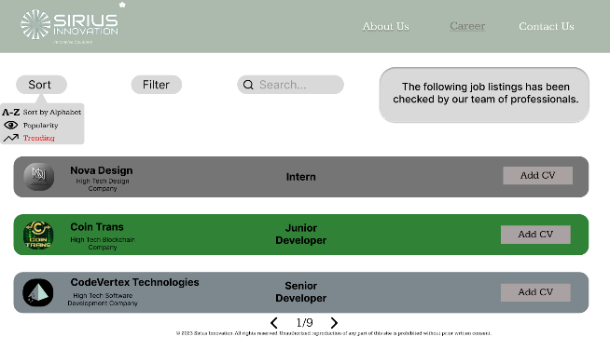
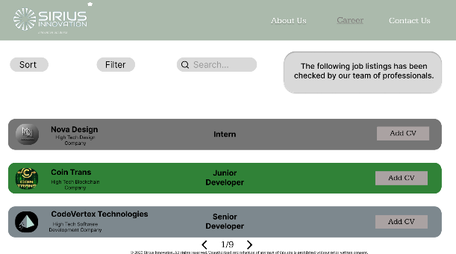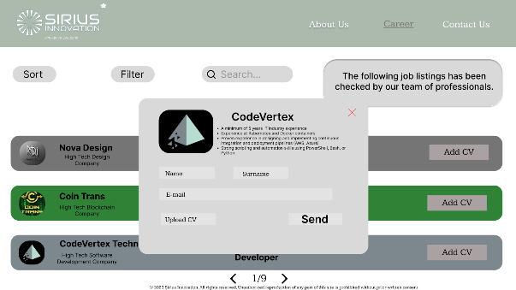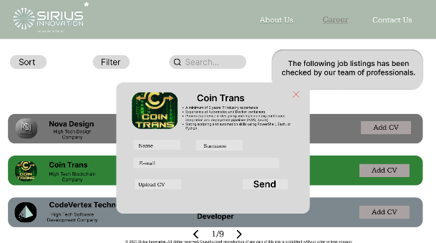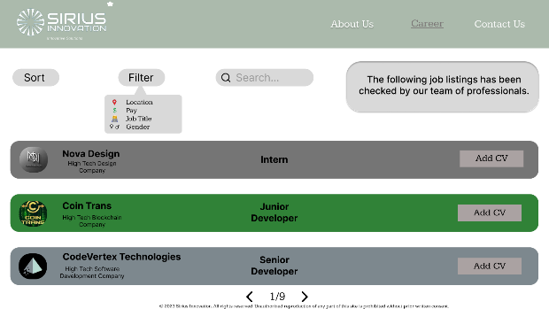
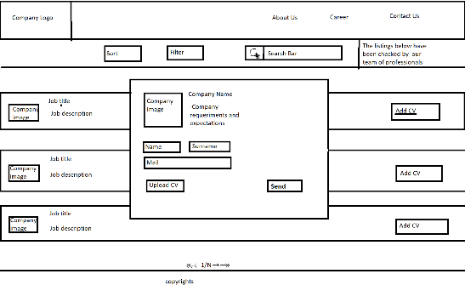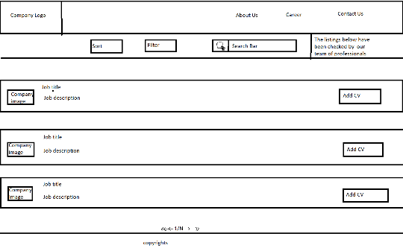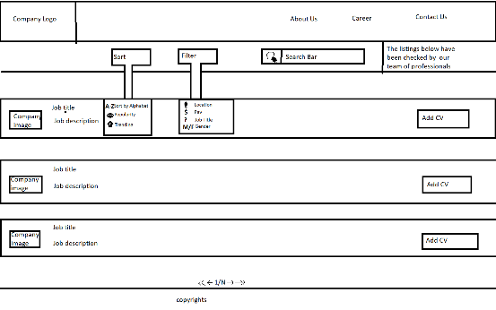

Contact Us
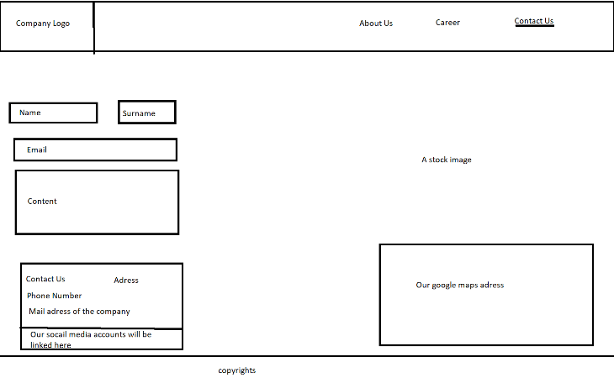
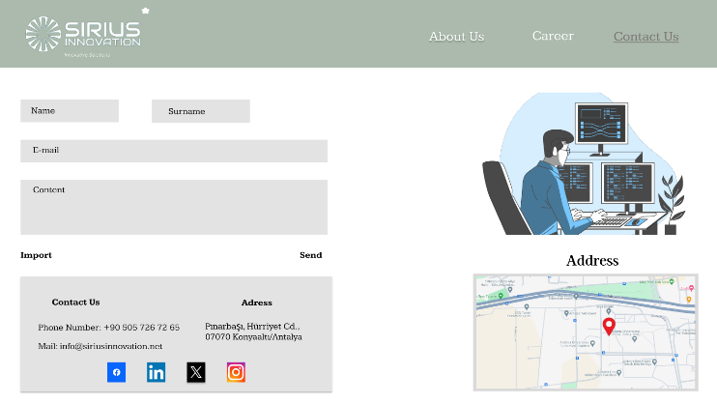

Predictive Evaluation

- Contacting Us:
MPBMPBHnKxHPBHmxKHPBHpxKHPBHbxKHPB
- Search a Job Using Search Bar:
MPBMPBHnxKK(enter)
- Filter the Jobs Using Filter Button:
MPBMPBMPB
- Sort the Jobs Using Sort Button:
MPBMPBMPB
- Send CV:
MPBMPBMPBHnxKHPBHnxKH PBHnxKHPBMPBPB

Usability Inspection

After finishing work with our layouts, we as group members sit all together to overview our project, we linked all of our layouts on Figma to create close to real look to work on and that what we had:

1. We found that, in the forum page when user wants to add their cv they only saw the company logo and available position. So, we thought users couldn’t apply for jobs they do not know the requirements of so we decided to add a brief requirements section.

2. After finishing the work, we realized when user changed a page the button related to page, they are currently in doesn’t show any indication so we thought it might cause a confusion so we decided to highlight the buttons.

3. After doing our last checkups, we realized that users may change their opinions about applying for a job so we added a leave the page icon (X) so that users can leave the “Add CV” page and just turn back to the forum page.

Usability Testing

We’ve tested our design on 2 users, both our classmates, we gave them a task that includes them to open all the pages that are possible in the project. Here are the results:

What They Did Like:
Home Page
X: Home Page seems nice
Y: Home Page seems cool I liked the overlays

About us
X: I liked the milestones part.
Y: I agree it makes sense.

Forum
X: It seems cool as an outsider, other than that I liked that there are sort and filter buttons.
Y: Can’t agree more, I liked the buttons as well.

Contact Us
X: It seems nice, but Map section seems perfect.
Y: It’s the best page so far, I liked the map section and social media section.

Overall
X: In general, I liked the layouts it seems cool.
Y: I agree.

What They Didn’t Like:
Home Page
X: I don’t understand what the business does through the main page.
Y: I don’t understand it either, other than that I think the news section is a little bit big.

About us
X: Putting a header to the paragraph nearby the CEO part might be good.
Y: The slider buttons are confusing since they are the same colors as the milestone circles.

Forum
X: I believe sort, search and filter bar’s distance is too much.
Y: I agree with this.

Contact Us
X: How can I delete the file I imported when I click the import button
Y: That’s true

Overall
X: There are small problems that is fixable.
Y: There are small problems that is fixable.

